Hussain Alomran's Mood-Board

Font: monospace

Color Palette



Examples on the website:

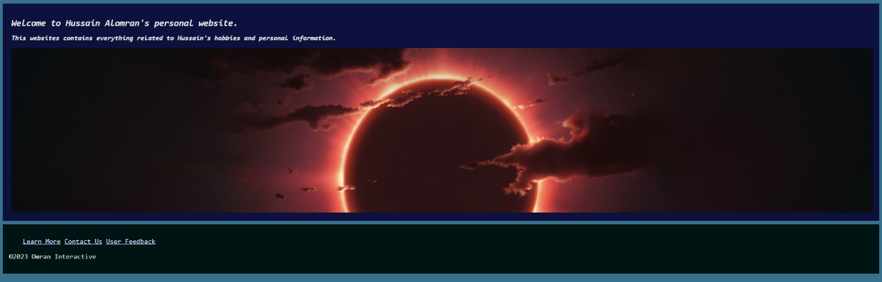1- Home Page

2- Details Page

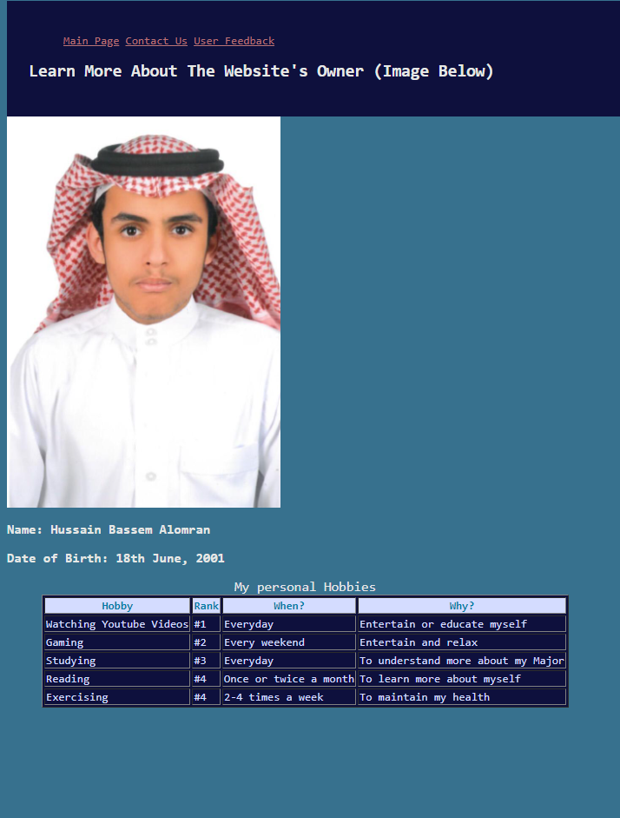

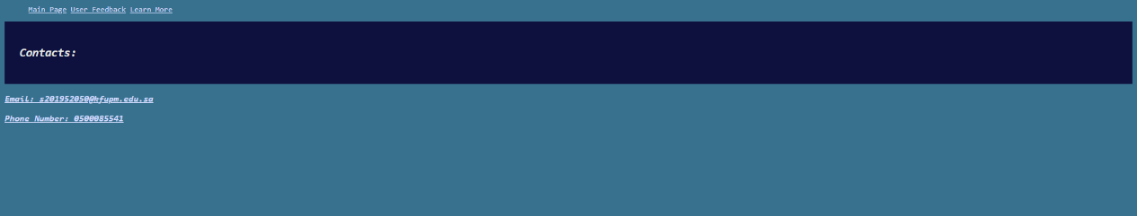3- Contacts Page

4- Survey

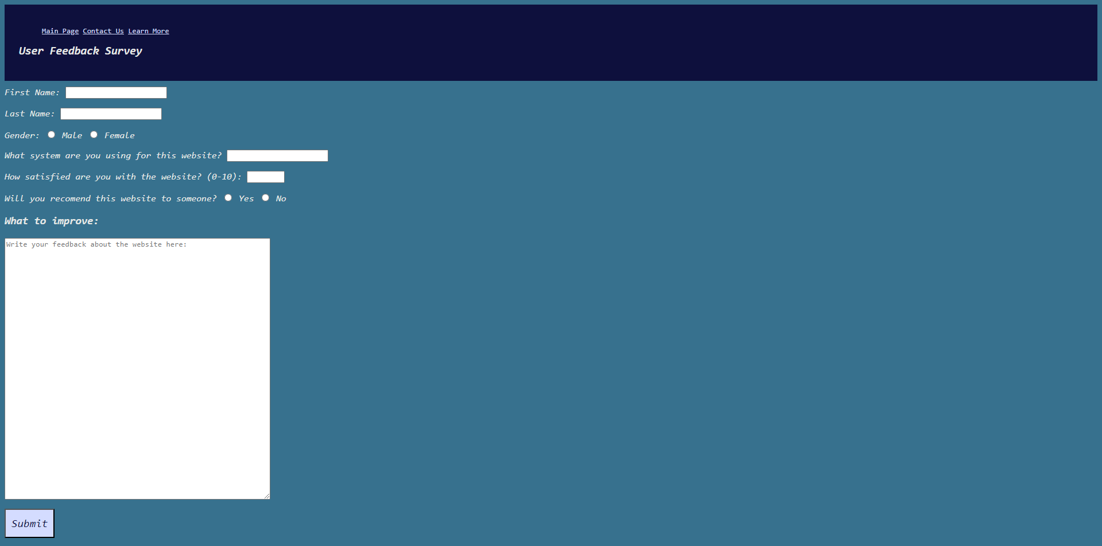

5- Thank you page

